On the Cellular Automata Technique for Globulitic and Dendritic Grain Growth Simulations

***Abstract-*** A two-dimensional cellular automata model is proposed to simulate globulitic and dendritic grain growth. In order to simulate growth in a bi-dimensional domain, this model initially uses a decentered growing circle to capture neighbor cells centers to simulate globulitic grains, and changing to the decentered square as used in traditional cellular automata technique when the grain becomes dendritic. First, parametric results for isolated globulitic and dendritic grain growth were analyzed, and then multiple grains results were compared with deterministic models available in literature.

***Keywords-*** cellular automata, globulitic, dendritic, grain growth, solidification, mathematical modeling.

## I. INTRODUCTION

T

he cellular automata (CA) technique is a known stochastic model that has been widely used to simulate dendritic grain growth in solidification problems [1]–[4]. This technique provides a picture of a calculated as-cast macrostructure of dendritic grains by simulating their nucleation, growth, and movement during solidification. However, in comparison with deterministic models in literature (REF), the CA technique in mesoscopic scale presents simpler equations for grain solidification rates (REF) as Scheil or lever rule, and rarely simulates globulitic growth in early stages of solidification (REF). In this work, a bidimensional CA model is used to provide individual grains domains in which a set of microscopic conservation equations is discretized and solved. A set of macroscopic of conservation uses information from the microscopic scale (micro-macro coupling) to calculate temperature and average liquid solute content in a representative elementary volume (REV).

In order to extend the CA technique to simulate globulitic growth, decentered circles are used as an alternative to the decentered squares used in precursor cellular automata models [4]. The circles change into decentered squares as grains become dendritic.

## II. METHODOLOGY

*A. Definitions of Microscopic and Macroscopic Domains*

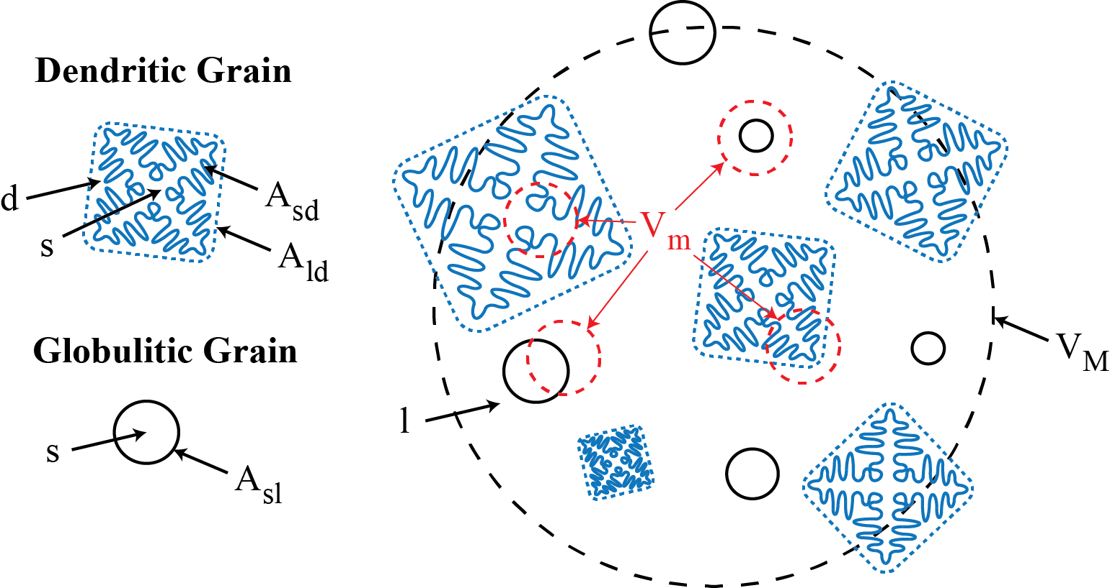

Fig. 1 In the left, the definition of two types of grains (dendritic and globulitic), and their pseudo-phases (“s” for primary solid, “d” for interdendritic liquid). In the right, both macroscopic () and microscopic () REVs are represented with the external liquid pseudo-phase (denoted by “l”)

The dendritic envelope model proposed by Wang and Beckermann [7] is used to define phases and pseudo-phases (where the sub-indexes “s” denotes the primary solid, “d” is the interdendritic liquid and “l” is the external, surrounding the grain envelopes).

*B. Macroscopic Model*

A set of conservation differential equations is defined for a REV in the macroscopic domain, as described in previous deterministic models [6]–[8]. The following set of governing equations represents respectively the mixture energy conservation, solute conservation for interdendritic liquid, and solute conservation for the external liquid:

|  |  |  |
| --- | --- | --- |
|  | | (1) |
|  | | (2) |
|  | (3) | |

where , and are the average temperature, and average solute concentrations for interdendritic liquid and external over the tri-dimensional macroscopic REV; , and are the phase transformation rate given by:

|  |  |
| --- | --- |
|  | (4) |

is the latent heat for fusion per unit of mass; is the specific heat per unit mass; is the heat extraction per unit volume; and are the specific area between phases. The heat extraction is assumed to be constant during all simulation time.

In order to obtain

|  |  |
| --- | --- |
|  | (4) |

*C. Microscopic Model*

|  |  |  |
| --- | --- | --- |
|  | | (6) |
|  | (7) | |
|  | (7) | |

*D. Cellular Automata Model*

*i. States of a cell*

A two dimensional structured mesh of CA cells was initially defined. At any moment during simulation, each cell can be at three possible states [5]: free, active or inactive. Free cells contain only liquid and are not part of any grain in the domain. Active cells have a square or circle that has a predefined orientation and that grows until its boundaries reach the center of neighbor cells, activating them. When the growth square/circle reaches the necessary size to capture all nearest neighbors, the cell becomes inactive and the square/circle no longer grows during simulation.

*ii. Nucleation*

Free cells may contain a particle, which can work as a solid substrate for heterogeneous nucleation. Each substrate particle holds a different critical undercooling for nucleation that, if reached, changes a free cell into an active one, creating a new growth square/circle that represents a new grain. Before starting a simulation, substrates per unit area were distributed randomly among the CA cells. The value of is calculated from the number density of substrate particles per unit volume as follows [1]:

|  |  |
| --- | --- |
|  | (1) |

When a cell is activated by nucleation, a growth square/circle with an arbitrarily small initial size is created at the center of the cell.

*iii. Growth and Capture*

Active cells can be classified as dendritic or globulitic. For the dendritic type, the decentered square defined in the original cellular automata models [2][4] is used to simulate grain growth, as illustrated in Fig. 2.

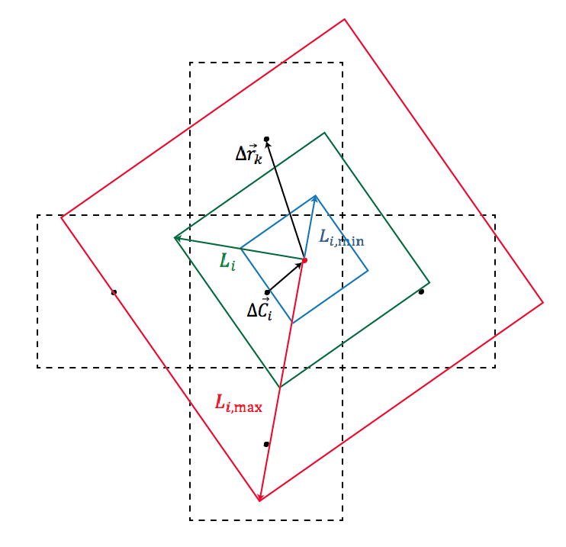

Fig. 2 A decentered square with decentralization vector and half-diagonal growing inside a CA cell, where is the initial size when the cell was activated, and is the limit size enough to capture all four neighbors cells centers, which distance is given by .

The approximated dendritic grain fraction inside a CA cell for a decentered square is given by:

|  |  |
| --- | --- |
|  | (2) |

where is the size of half-diagonal of the square, is the initial size, defined when the cell is activated by capture or nucleation, and is the minimum size necessary to capture all four centers of nearest neighbor cells. For globulitic cells, a growth circle is created on activation, rather than a growth square to capture other cells (Fig. 3). The approximated globulitic grain fraction inside a CA cell ( for a decentered circle is given by:

|  |  |
| --- | --- |
|  | (3) |

where is the instantaneous radius of the growth circle, is the initial radius, defined when the cell was activated, and is, again, the minimum size necessary to capture all four centers of nearest neighbor cells.

Each active cell represents a part of a grain boundary and consequently a segment of the grain perimeter on the two-dimensional projection. For globulitic grains, a relation to calculate the segment length is proposed based on the angle obtained by selecting the minimum positive and negative (in modulus) orientation difference between the vector (the distance vector from the grain’s original nucleation cell to the center of the cell ) and its active neighbors.

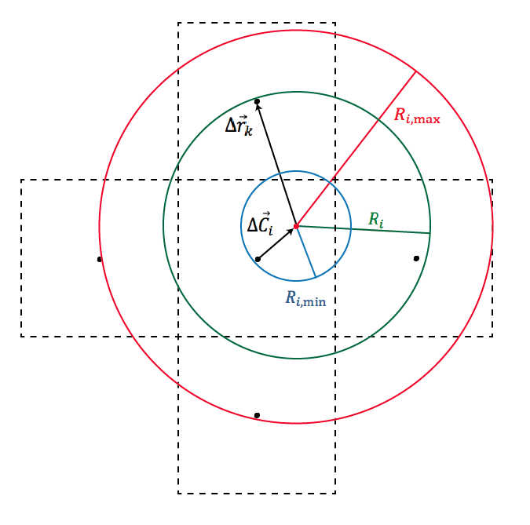

Fig. 3 A decentered circle scheme with a growing radius , and its initial size , limit size and decentralization and neighbor cell center distance analogous to the decentered square illustrated on Fig. 2.

(diagonal neighbors are included). Then, the grain perimeter segment associated with a cell is given by:

|  |  |
| --- | --- |
|  | (4) |

and the total grain perimeter per unit area, , by:

|  |  |
| --- | --- |
|  | (5) |

*iv. Kinetics, Effective Diffusion Length and Solid-Liquid Interface Local Equilibrium*

For dendritic grains, the growth velocity of the diagonal of the growth square is calculated as [REFERENCIA]:

|  |  |
| --- | --- |
|  | (6) |

where is the solute diffusivity in the liquid phase, is the liquidus line slope and is the partition coefficient for the binary alloy, is the equilibrium solute concentration for a given temperature, is the Gibbs-Thompson coefficient, is the inverse Ivantsov function and is a dimensionless undercooling. For globulitic grains, the growth velocity of the growth circle radius is calculated by:

|  |  |
| --- | --- |
|  | (7) |

where is the average solute concentration of the liquid surrounding grains, the effective diffusion length calculated as shown by Martorano et al. (2003) [6] for a growing sphere of radius inside a unitary cell of radius . In order to account for different grain sizes in the domain, the size of an unitary cell is slightly different than the original equation used by NOME[6]:

where is the volumetric fraction of the grain that contains the cell , and is the total volumetric grain fraction.

Finally, globulitic grains become dendritic if and calculated by dendritic growth is larger than .

## III. NUMERICAL RESULTS

*i. Isolated Grain Growth*

Each active cell represents a part of a grain boundary and consequently a segment of the grain perimeter on the bi-dimensional projection. For globulitic grains, a relation to calculate the segment

TABLE I

PARAMETERS FOR AN ISOLATED GRAIN WITH CONSTANT GROWTH KINECTICS

|  |  |
| --- | --- |
|  | m |
|  | m/s |
|  | 201x201 |

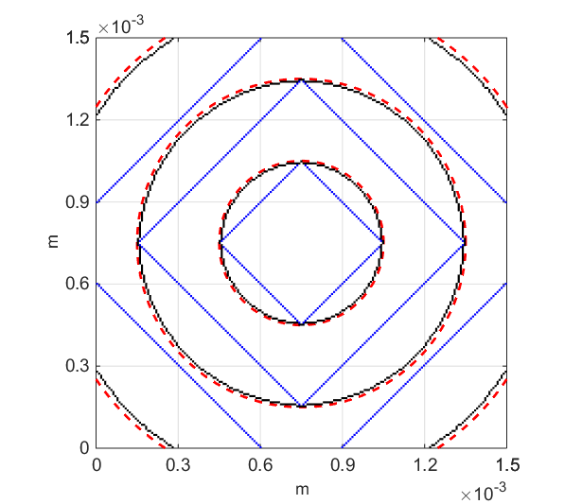

Fig. 4 A decentered circle scheme with a growing radius , and its initial size , limit size and decentralization and neighbor cell center distance analogous to the decentered square illustrated on Fig. 2.



Fig. 3 Evolution of grain fraction over area domain () and grain perimeter per unit area () for a (a) decentred circle, (b) decentred square with diagonal oriented 0° and (c) 30° with 101x101 and 201x201 meshes in comparison with analytical solutions.

TABLE II

PARAMETERS FOR AN ISOLATED GLOBULITIC EUCTECTIC GRAIN WITH TEMPERATURE GRADIENT

|  |  |
| --- | --- |
|  | m |
|  | K/m |
|  | 0.1 m/s |

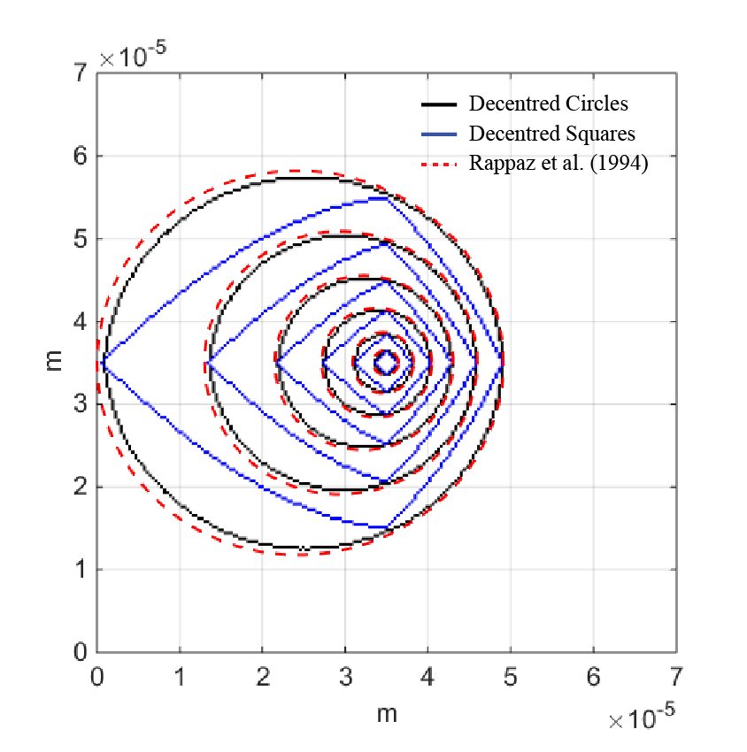

Fig. 4 Comparison of the evolution of undercooling of the present model, Martorano et al. (2015) and Quested and Greer (2004)

*iii. Multiple Globulitic and Dendritic Grains nucleating instantaneously*

|  |  |
| --- | --- |
|  | (15) |



Fig. 6 Comparison of the evolution of undercooling of the present model, Martorano et al. (2015) and Quested and Greer (2004)

*ii. Multiple Globulitic Grain Growth with a Continuous Nucleation Model*

|  |  |
| --- | --- |
|  | (12) |

|  |  |
| --- | --- |
|  | (18) |

|  |  |
| --- | --- |
|  | (18) |

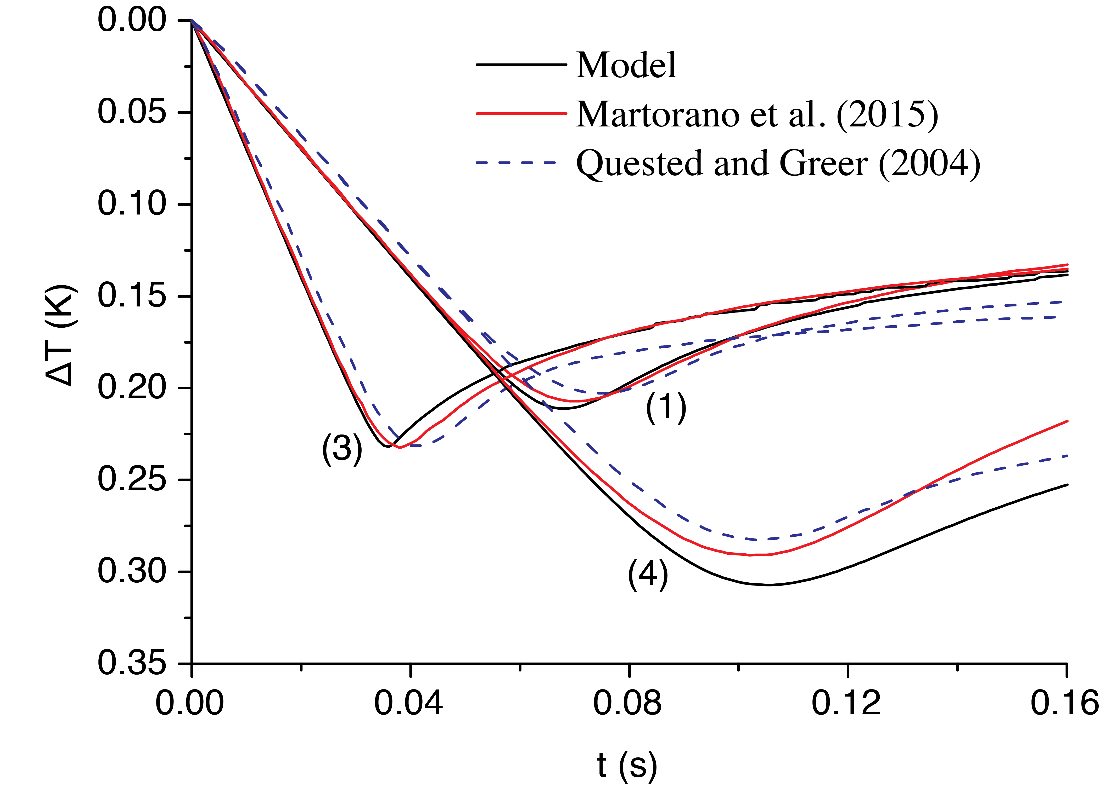

Fig. 3 Comparison of the evolution of undercooling of the present model, Martorano et al. (2015) and Quested and Greer (2004)

TABLE II

PARAMETERS FOR AN ISOLATED GLOBULITIC EUCTECTIC GRAIN WITH TEMPERATURE GRADIENT

|  |  |
| --- | --- |
|  | m |
|  | m/s |
|  | 201x201 |

## IV. CONCLUSION

A cellular automata model was proposed to simulate globulitic and dendritic grains, using a kinectic criteria to emulate transition between these morphologies. The model geometric relations showed _____ with analytical results. In comparison to the “shooting method”, the model also calculated an approximated elliptic shape for an imposed temperature gradient condition. For an isothermal solidification system containing multiple globulitic grains nucleated in different instants, the model presented a behavior similar to an implementation of a deterministic model.

## REFERENCES

[1] M. Rappaz and C. Gandin, “Probabilistic modelling of microstructure formation in solidification processes,” *Acta Metall. Mater.*, vol. 41, no. 2, pp. 345–360, 1993.

[2] G. Guillemot, C. Gandin, and H. Combeau, “Modeling of macrosegregation and solidification grain structures with a coupled cellular automaton-: Finite element model,” *ISIJ Int.*, vol. 46, no. 6, pp. 880–895, 2006.

[3] M. A. Martorano and V. Biscuola, “Predicting the columnar-to-equiaxed transition for a distribution of nucleation undercoolings,” *Acta Mater.*, vol. 57, no. 2, pp. 607–615, Jan. 2009.

[4] C. Gandin and M. Rappaz, “A 3D cellular automaton algorithm for the prediction of dendritic grain growth,” *Acta Mater.*, vol. 45, no. 5, pp. 2187–2195, 1997.

[5] S. Gregorio and R. Serra, “An empirical method for modelling and simulating some complex macroscopic phenomena by cellular automata,” *Futur. Gener. Comput. Syst.*, vol. 16, no. 2–3, pp. 259–271, Dec. 1999.

[6] M. A. Martorano, C. Beckermann, and C. -a. Gandin, “A solutal interaction mechanism for the columnar-to-equiaxed transition in alloy solidification,” *Metall. Mater. Trans. A*, vol. 34, no. 8, pp. 1657–1674, Aug. 2003.

[7] C. Wang and C. Beckermann, “A multiphase solute diffusion model for dendritic alloy solidification,” *Metall. Trans. A*, vol. 24, no. December, 1993.

[8] C. Wang and C. Beckermann, “Equiaxed dendritic solidification with convection: Part I. Multiscale/multiphase modeling,” *Metall. Mater. Trans. A*, vol. 27, no. 9, pp. 2754–2764, Sep. 1996.

[9] M. Rappaz, C. Charbon, and R. Sasikumar, “About the shape of eutectic grains solidifying in a thermal gradient,” *Acta Metall. Mater.*, vol. 42, no. 7, pp. 2365–2374, 1994.

[10] T. . Quested and a. . Greer, “The effect of the size distribution of inoculant particles on as-cast grain size in aluminium alloys,” *Acta Mater.*, vol. 52, no. 13, pp. 3859–3868, Aug. 2004.